OOP-LAB Task 8

Roll No: 24P-0706 | Dept: BS-CS
Name: Aazan Noor Khuwaja | Section : 2D

QNS-1:
#include<iostream>
using namespace std;
class time{
int hours , minutes , seconds;
public:
time(){
hours = 0;
minutes = 0;
seconds = 0;
};
time(int h, int m, int s){
hours = h;
minutes = m;
seconds = s;
};
void display(){
cout<<hours<<":"<<minutes<<":"<<seconds<<endl;
};
time operator+(time t){
time temp;
temp.seconds = seconds + t.seconds;
temp.minutes = minutes + t.minutes + (temp.seconds / 60);
temp.hours = hours + t.hours + (temp.minutes / 60);
temp.seconds %= 60;
temp.minutes %= 60;
return temp;
};
};
int main(){
time t1(2, 30, 45);
time t2(1, 45, 50);
time t3 = t1 + t2;
cout<<"Time 1: ";
t1.display();
cout<<"Time 2: ";
t2.display();
cout<<"Sum of (Time 1 and Time 2 ): ";
t3.display();
return 0;
}

Output: 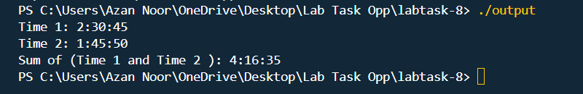

QNS-2:
Code:
#include<iostream>
using namespace std;
class matrix{
public:
int mat[2][2];
matrix(int a, int b, int c, int d){
mat[0][0] = a;
mat[0][1] = b;
mat[1][0] = c;
mat[1][1] = d;
};

matrix operator+(matrix m){
matrix temp(0, 0, 0, 0);
for (int i=0;i<2;i++){
for (int j=0;j<2;j++){
temp.mat[i][j] = mat[i][j] + m.mat[i][j];
}
}
return temp;
}

matrix operator*(matrix m){
matrix temp(0, 0, 0, 0);
for (int i=0;i<2;i++){
for (int j=0;j<2;j++){
temp.mat[i][j] = mat[i][j] * m.mat[i][j];
}
}
return temp;
}

bool operator==(matrix m){
for (int i=0;i<2;i++){
for (int j=0;j<2;j++){
if (mat[i][j] != m.mat[i][j]){
return false;
}
}
}
return true;
}

};

int main(){
matrix m1(1, 2, 3, 4);
matrix m2(1, 2, 3, 4);
matrix m3 = m1 + m2;
matrix m4 = m1 * m2;
bool m5 = m1 == m2;
cout<<"Sum of Matrix 1 and Matrix 2: "<<endl;
for (int i=0;i<2;i++){
for (int j=0;j<2;j++){
cout<<m3.mat[i][j]<<" ";
}
}
cout<<endl;
cout<<"Product of Matrix 1 and Matrix 2: "<<endl;
for (int i=0;i<2;i++){
for (int j=0;j<2;j++){
cout<<m4.mat[i][j]<<" ";
}
}
cout<<endl;
cout<<"Matrix 1 and Matrix 2 are equal: "<<endl;
if (m5){
cout<<"Yes Equal"<<endl;
}

else{
cout<<"Not Equal"<<endl;
}
return 0;
}

Output:
